**file 18010055:**

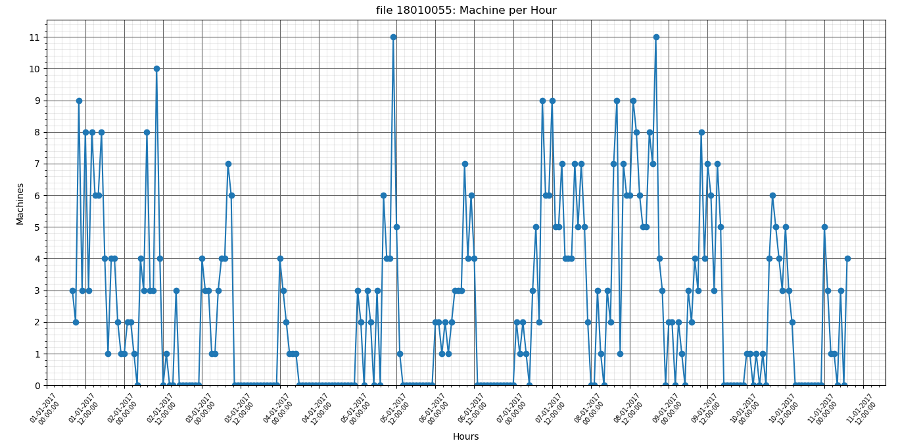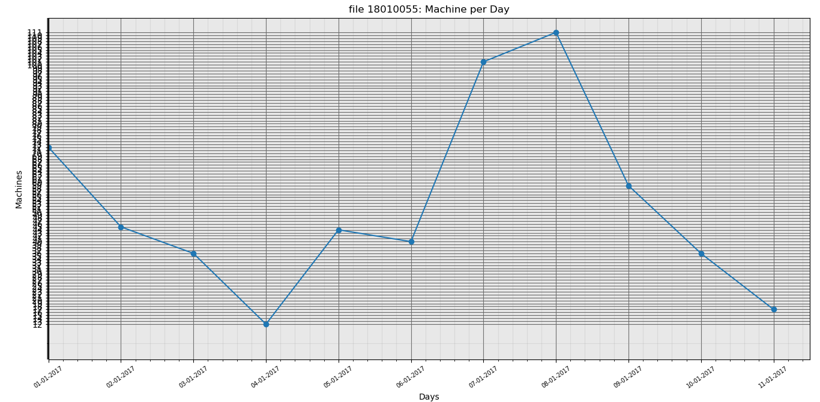

**Average machine count per day is: 47.750**

**Standard deviation is: 33.591**

**12189042**

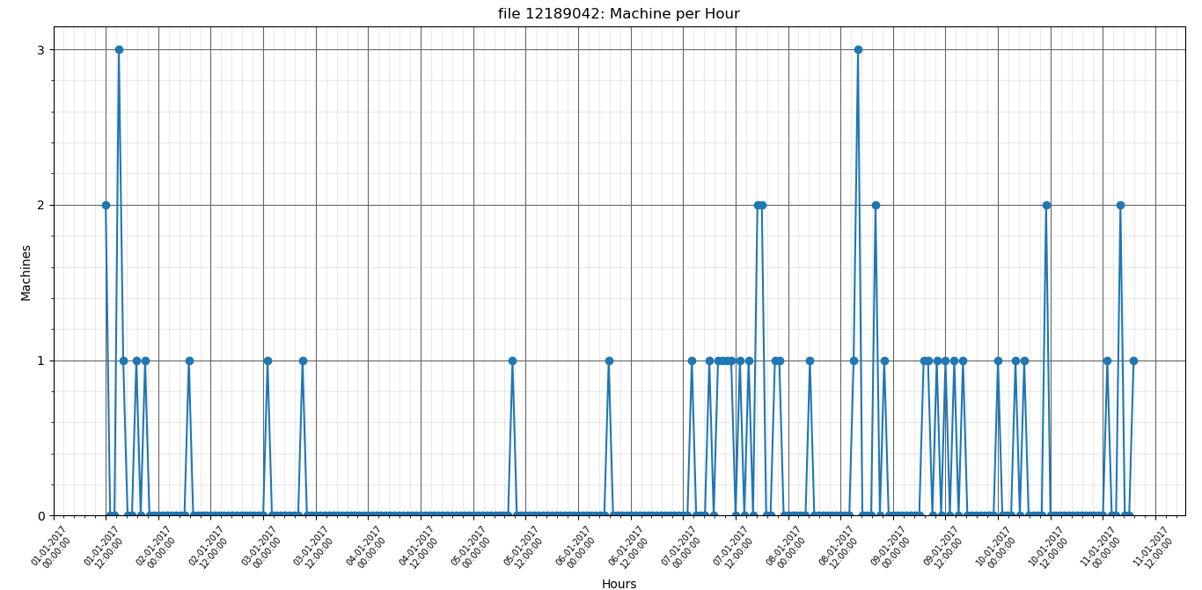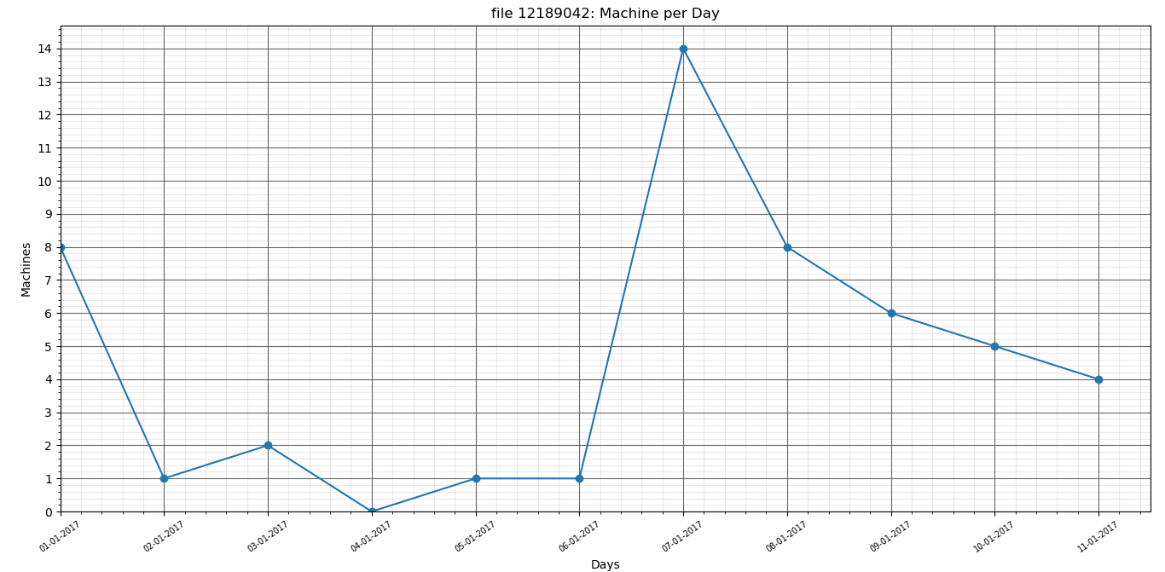

**file 12189042: Average machine count per day is: 4.167**

**file 12189042: Standard deviation is: 4.260**

**9717952**

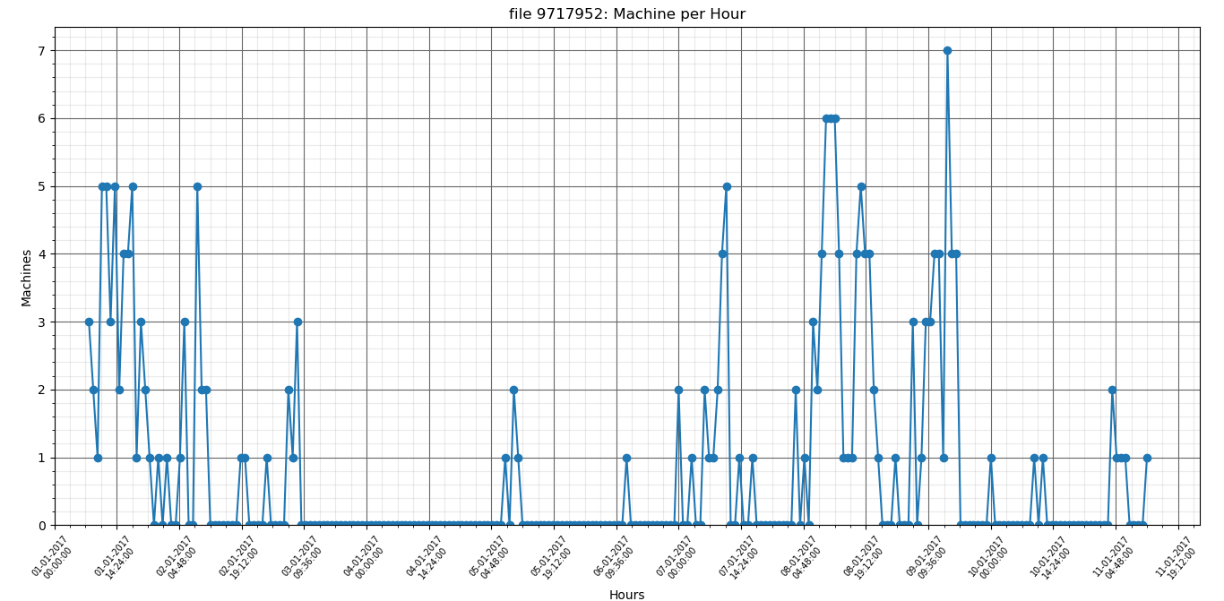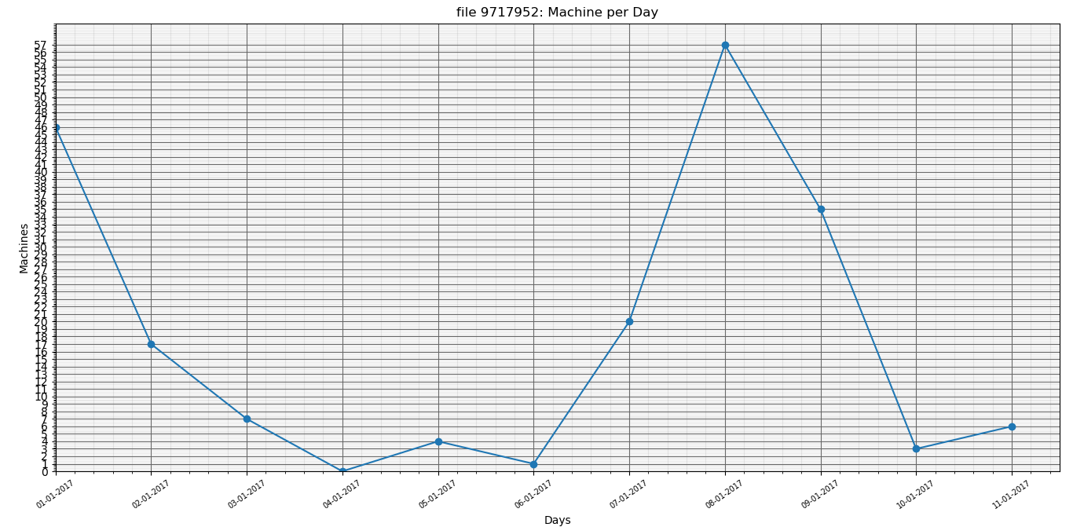

**file 9717952: Average machine count per day is: 16.333**

**file 9717952: Standard deviation is: 19.514**

**6637411**

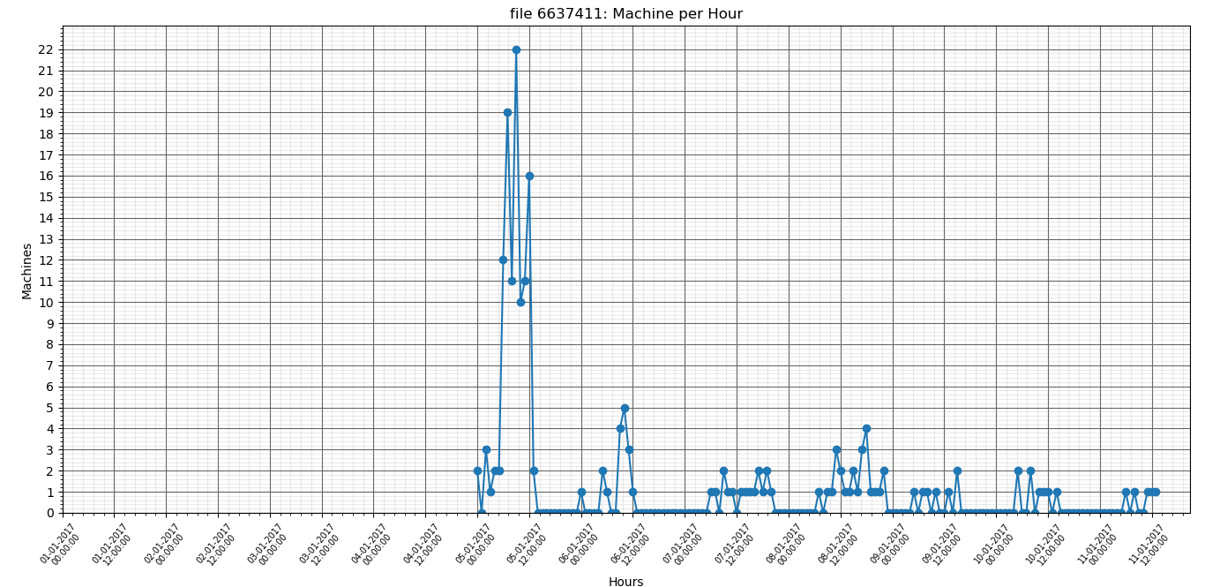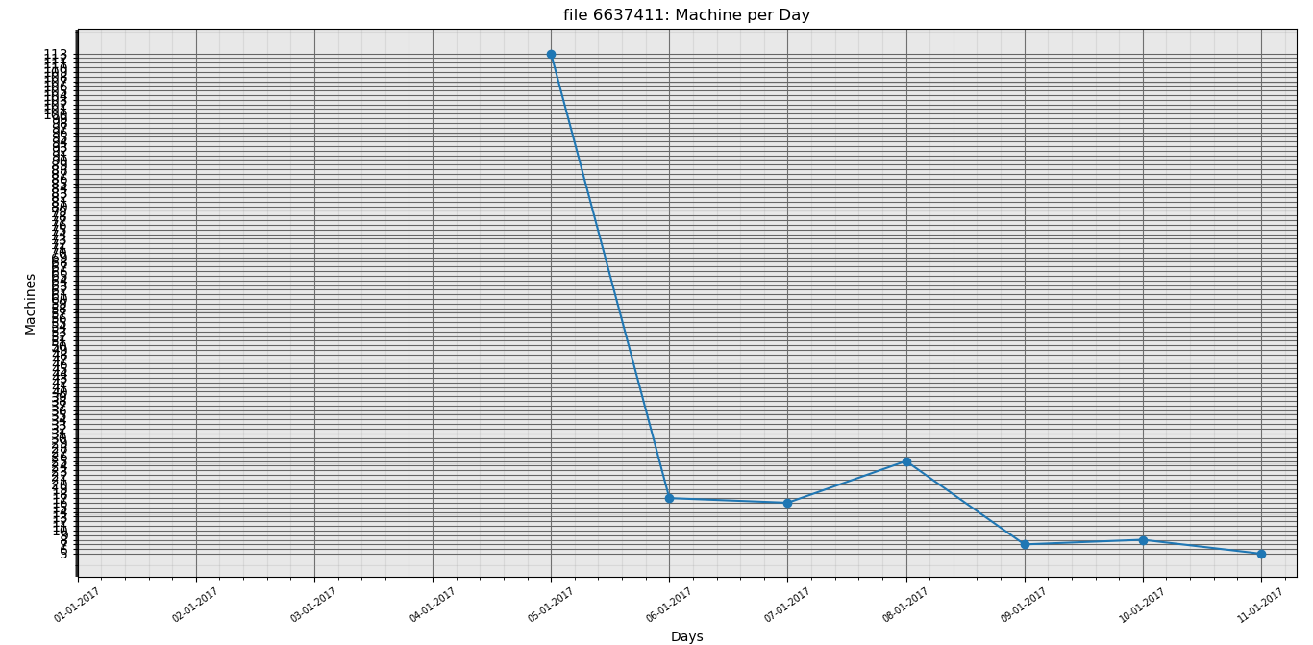

**file 6637411: Average machine count per day is: 15.917**

**file 6637411: Standard deviation is: 31.676**